Banner both side
size : (w) 2’5” x (h) 5’
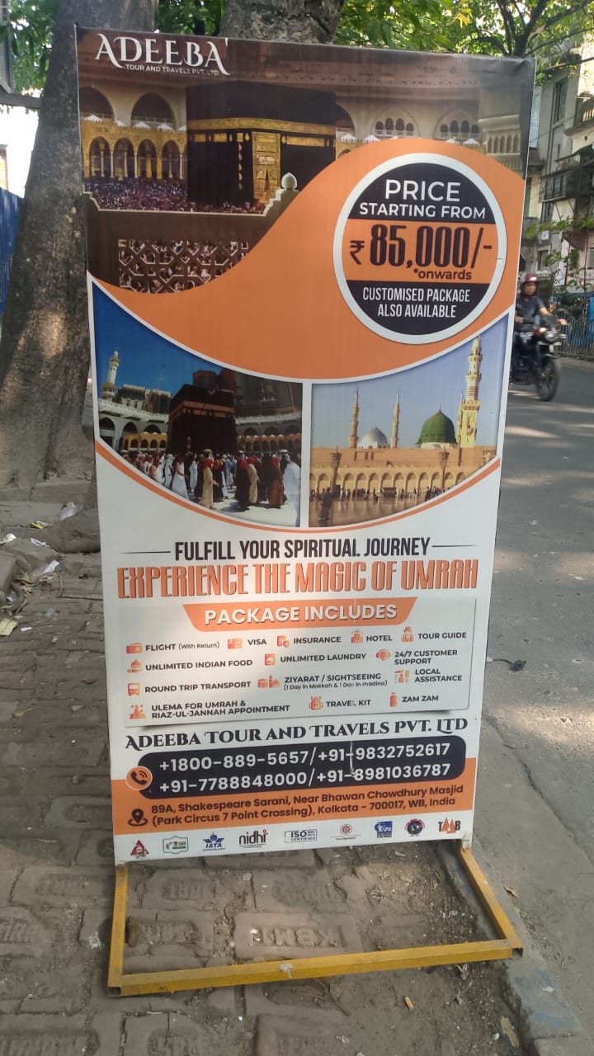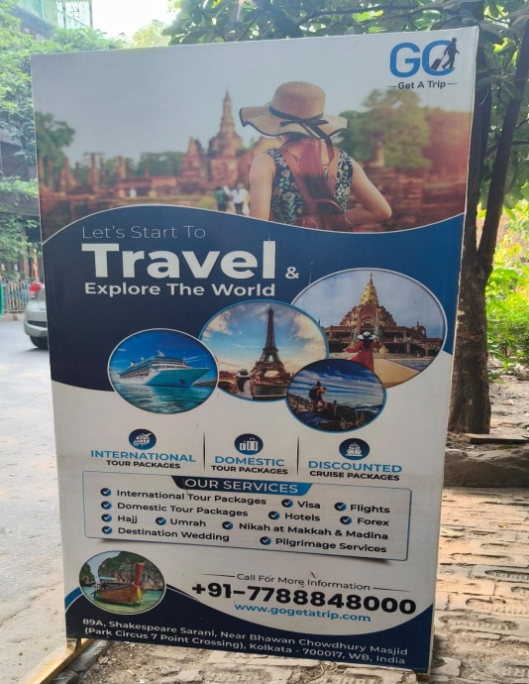
Entrance Gate Sticker
size: (w) 3’ x (h) 7’

- Right Side: Adeeba Tour and Travels [Company name, Logo, Address]
- Left Side: Aleena Arfeen Hajj and Umrah Pvt. Ltd. [Company name, Logo, Address]
